**PRACTICAL: 7**

**Design the UI using any Visual Communication Elements of interface Design.**

Visual communication is a crucial aspect of interface design, as it directly influences how users interact with and perceive a digital product. Here are 20 key visual communication elements in interface design, along with detailed explanations:

Interface design, also known as user interface (UI) design, is a multidisciplinary field that focuses on creating visually appealing and user-friendly interfaces for digital products, such as websites, mobile applications, and software. The primary goal of interface design is to enhance the user experience by ensuring that the interaction between the user and the system is intuitive, efficient, and enjoyable.

In brief, interface design involves the creation of graphical elements, navigation structures, and interactive components that facilitate effective communication between users and the digital product. It encompasses various aspects, including visual aesthetics, usability, accessibility, and overall user satisfaction. Interface designers work to strike a balance between functionality and aesthetics, aiming to deliver a seamless and pleasing experience for users.

Visual communication elements of interface design:

1. **Layout:** The arrangement of visual elements on the screen, determining the overall structure and flow of the interface.
2. **Grid Systems:** A framework of horizontal and vertical lines that helps designers organize content and maintain consistency.
3. **Typography:** The choice of fonts, font sizes, and spacing to ensure legibility and convey hierarchy.
4. **Color Scheme:** The selection of colors to create a visually appealing and harmonious design, considering brand identity and user psychology.
5. **Images and Icons:** The use of visuals, such as images and icons, to enhance understanding and provide a more engaging user experience.
6. **Buttons:** Interactive elements that users click or tap to perform actions, often designed with a distinct appearance to attract attention.
7. **Forms:** Input fields, checkboxes, radio buttons, and other elements that enable users to submit information or make selections.
8. **Navigation Menus:** Systems for guiding users through the interface, typically including menus, breadcrumbs, and navigation bars.
9. **Feedback Elements:** Visual cues, such as animations or messages, to inform users about the status of their actions or system processes.
10. **Progress Indicators:** Visual elements that show users the completion status of a task or loading process.
11. **Cards:** Containers that hold related information, making content more digestible and organized.
12. **Whitespace (Negative Space):** The use of empty space to enhance readability, separate elements, and create a clean, uncluttered design.
13. **Responsive Design:** Ensuring that the interface adapts seamlessly to different screen sizes and devices.
14. **Consistency:** Maintaining a uniform design language throughout the interface to improve user predictability and recognition.
15. **Accessibility Features:** Design considerations to ensure that the interface is usable by people with diverse abilities.
16. **Microinteractions:** Small, subtle animations or visual effects that provide feedback and enhance the overall user experience.
17. **Call-to-Action (CTA):** Design elements that prompt users to take specific actions, often highlighted to attract attention.
18. **Loading Animations:** Visual elements that entertain or inform users during loading times, reducing perceived wait times.
19. **Error Handling:** Visual cues and messages that guide users when errors occur and provide assistance in resolving issues.
20. **User Onboarding:** Visual elements and interactions that help new users understand and navigate the interface more easily.

Step 1: Open Figma: Launch Figma and create a new project.

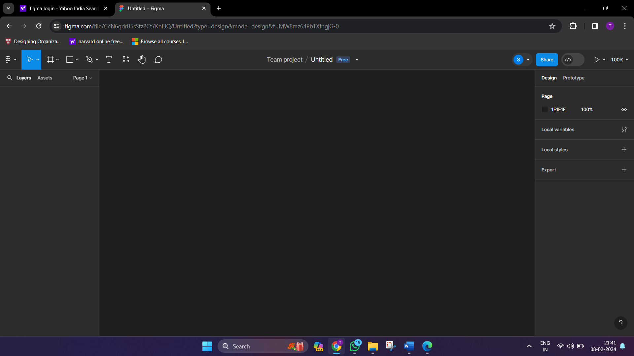

Step 2: Create a new frame to represent your design canvas.

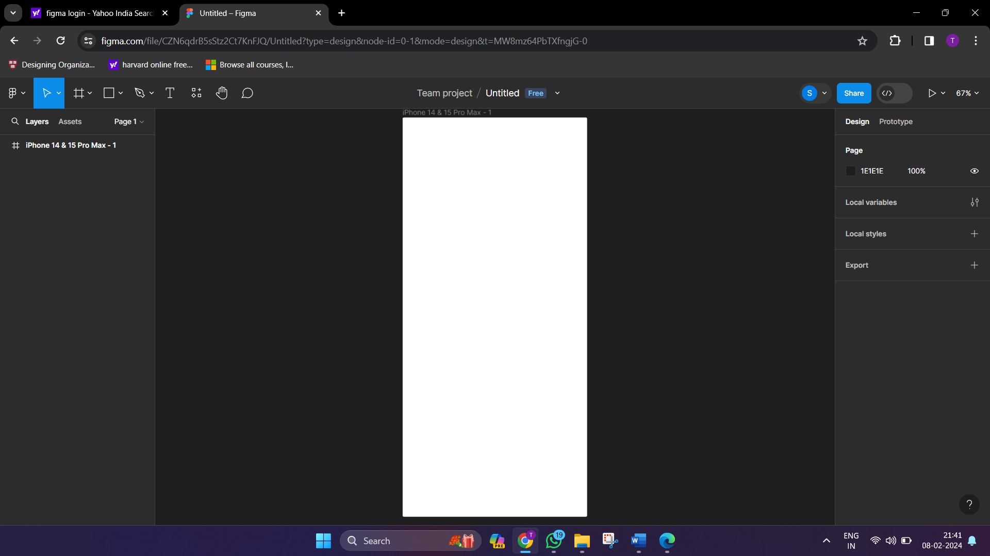

Step 3: Create a Home Page with all visual communication elements.

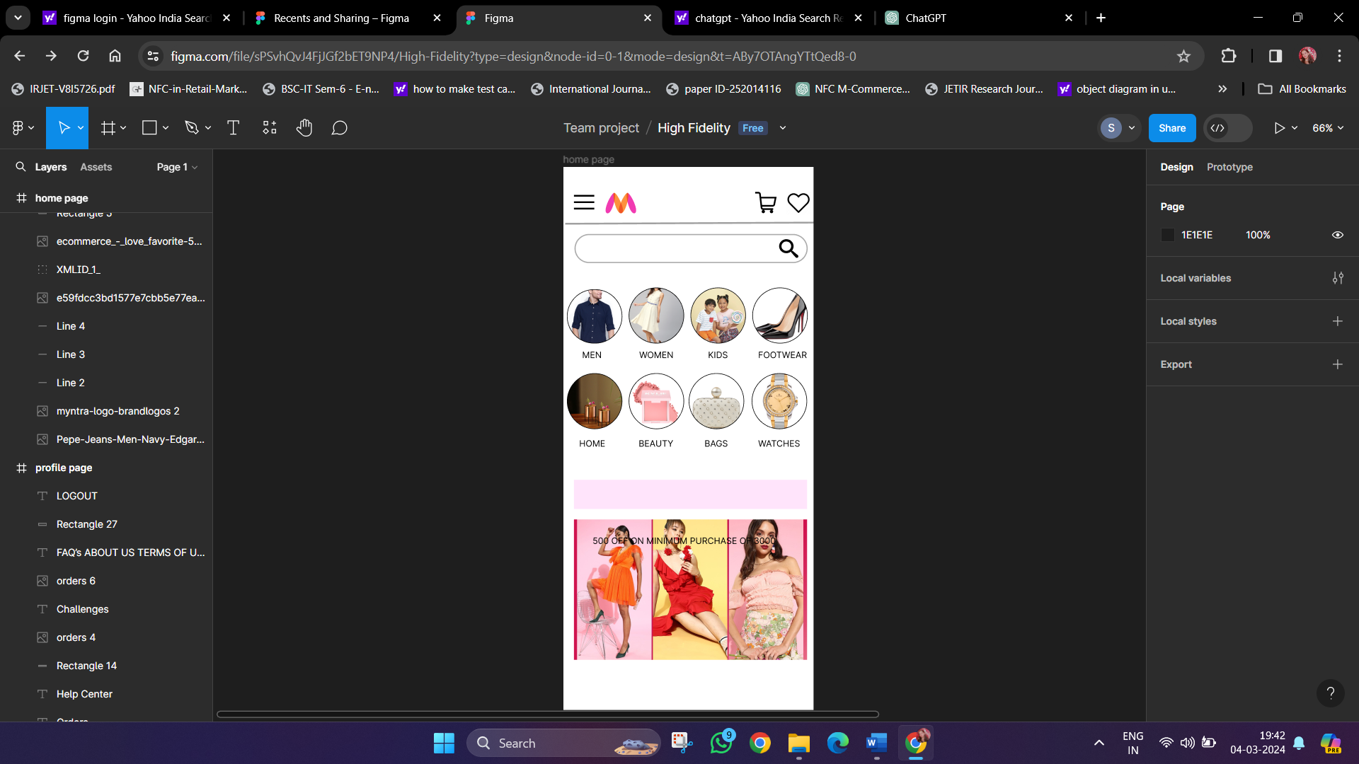

Step 4: Create a Profile Page with all visual communication elements.

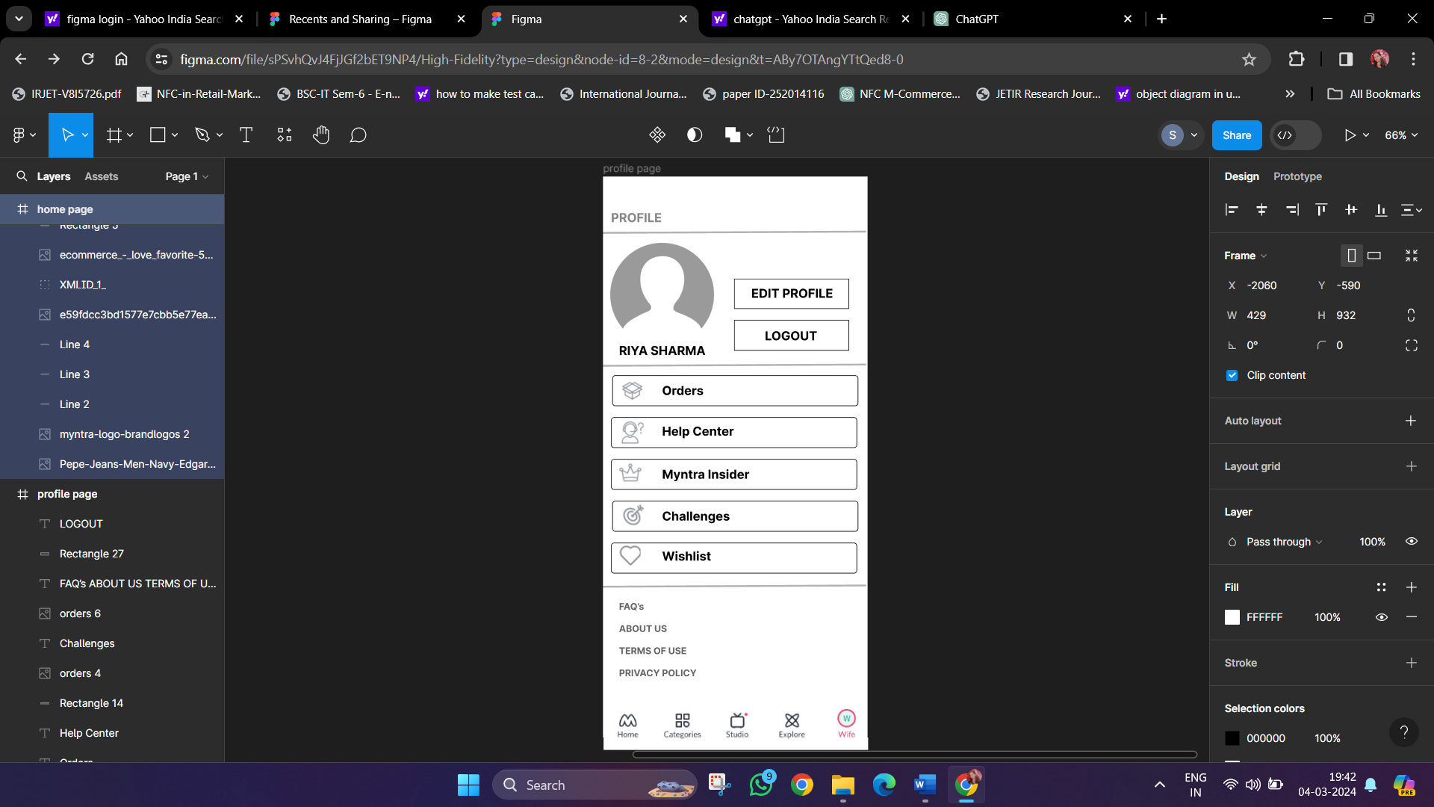

Step 5: Connect the two pages using Prototyping tool by adding navigation.

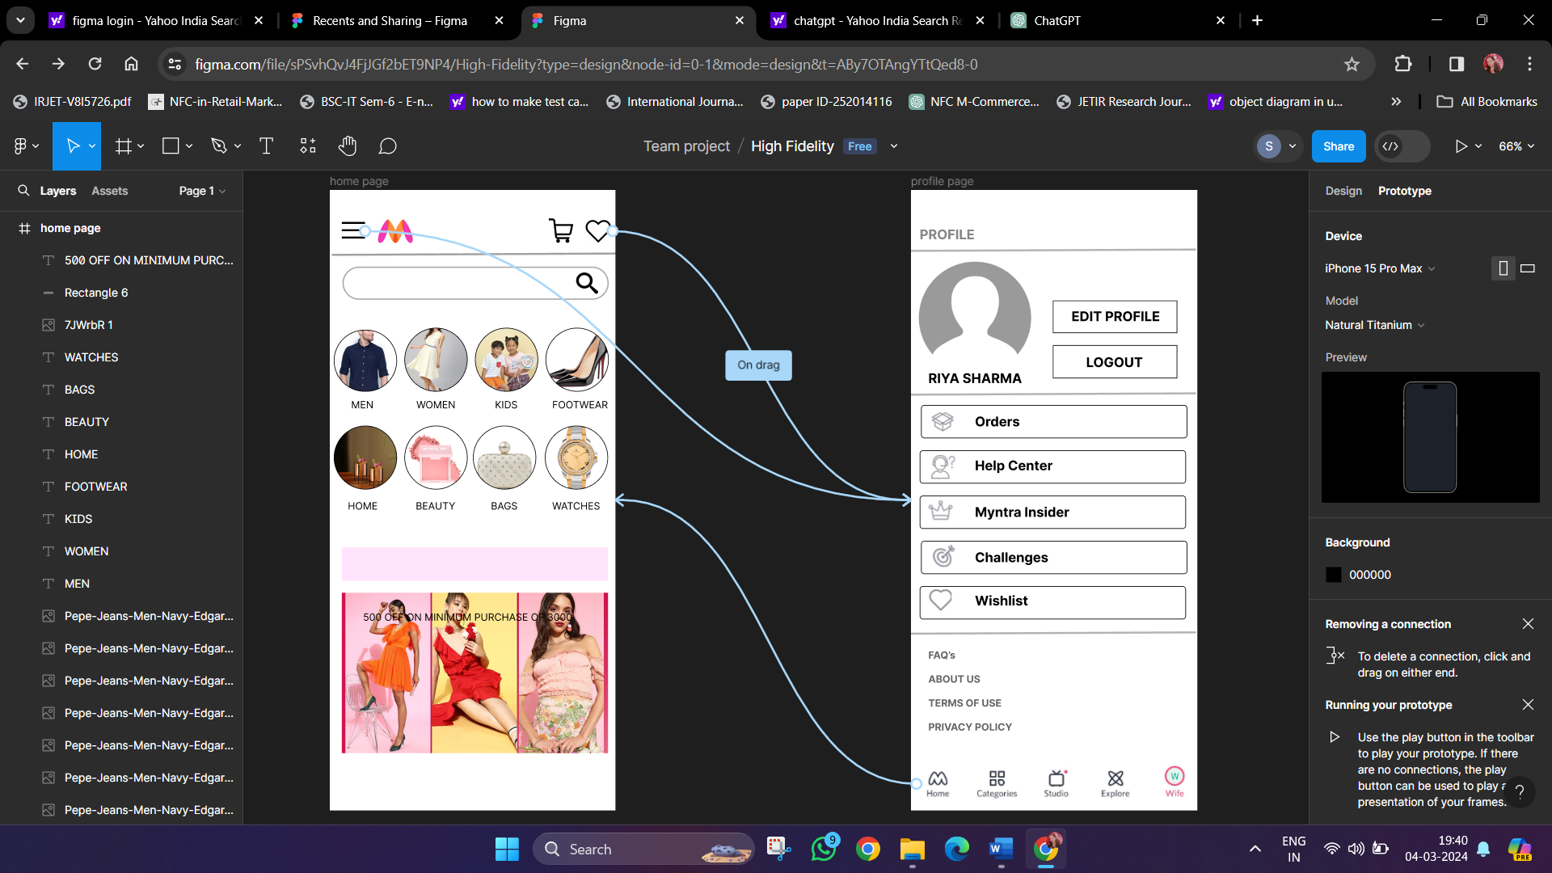

**Visual Communication elements used:**

Layout, Grid System, Typography, Color Scheme, Images, Icons, Buttons, Navigations and Responsive Design

